Naive Bayes
Instructions:

Topic: Naïve Bayes

Hints:
- Business Problem
  - What is the business objective?
  - Are there any constraints?

- Work on each feature of the dataset to create a data dictionary as displayed in the below image:
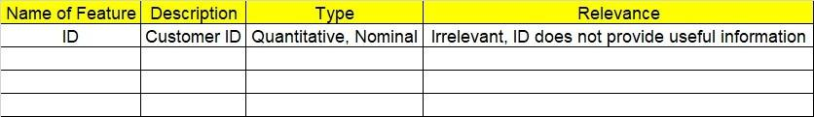
2.1 Make a table as shown above and provide information about the features such as its data type and its relevance to the model building. And if not relevant, provide reasons and a description of the feature.

- Data Pre-processing
3.1 Data Cleaning, Feature Engineering, etc.
- Exploratory Data Analysis (EDA):
  - Summary.
  - Univariate analysis.
  - Bivariate analysis.

- Model Building
  - Build the model on the scaled data (try multiple options).
  - Build a Naïve Bayes model.
5.3 Validate the model with test data and obtain a confusion matrix, get precision, recall, and accuracy from it.
5.4 Tune the model and improve the accuracy

6. Write about the benefits/impact of the solution - in what way does the business (client) benefit from the solution provided?

Problem Statement:
1.) Prepare a classification model using the Naive Bayes algorithm for the salary dataset. Train and test datasets are given separately. Use both for model building. 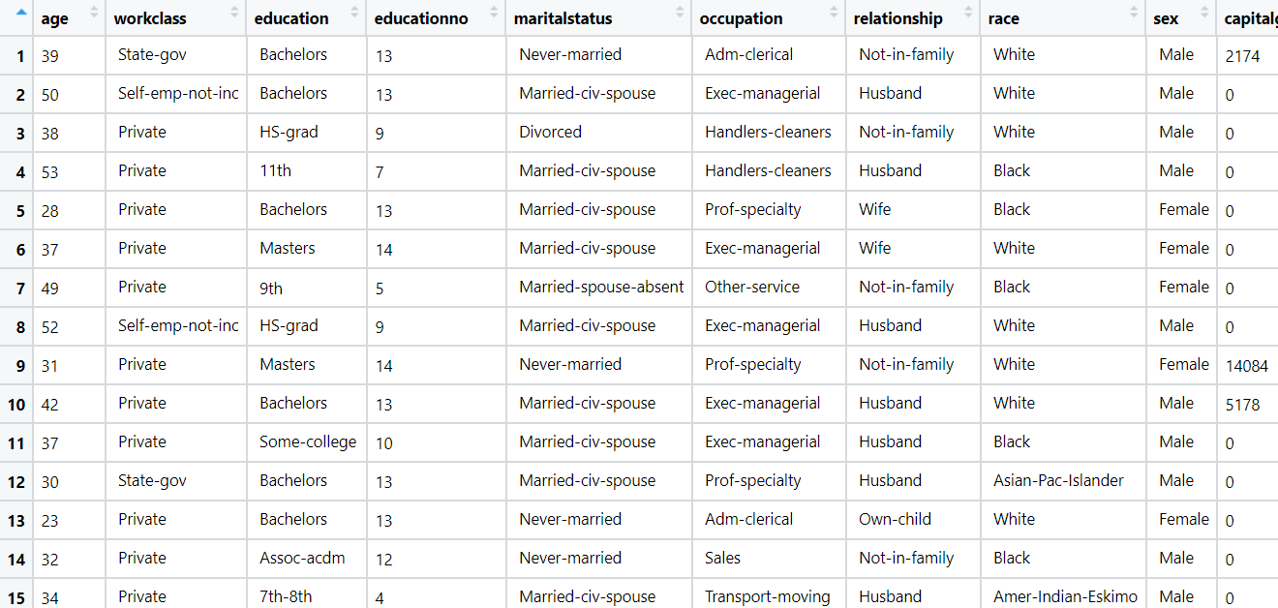

Problem Statement: -
This dataset contains information of users in a social network. This social network has several business clients which can post ads on it. One of the clients has a car company which has just launched a luxury SUV for a ridiculous price. Build a Bernoulli Naïve Bayes model using this dataset and classify which of the users of the social network are going to purchase this luxury SUV. 1 implies that there was a purchase and 0 implies there wasn’t a purchase.

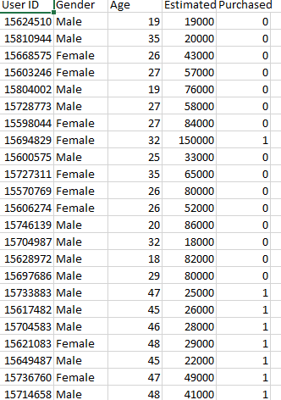

Problem Statement: -
In this case study, you have been given Twitter data collected from an anonymous twitter handle. With the help of a Naïve Bayes model, predict if a given tweet about a real disaster is real or fake.
1 = real tweet and 0 = fake tweet
